How to add internal repository in maven

1. In eclipse Windows-Preferences-Maven-user Setting

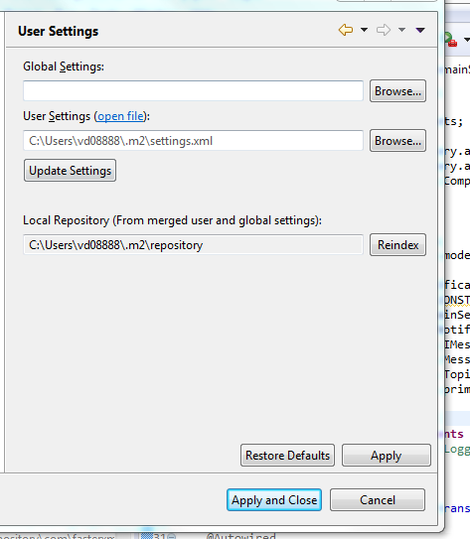

1. Update the password in attached setting.xml and place it in above location



1. In pom.xml add the repository (Please keep the id “jetblue-common-framework” as you defined in setting.xml)

<repositories>

<repository>

<id>jetblue-common-framework</id>

<name>jetblue framework repository</name>

<url>https://artifactory.it.jetblue.com/artifactory/libs-release</url>

</repository>

</repositories>

1. Now add the dependency in pom

<dependency>

<groupId>jbCommon</groupId>

<artifactId>jbCommon</artifactId>

<version>0.0.9</version>

</dependency>

1. Once you update the maven you able to see the jbCommon has been added



Attached the pom for our reference 